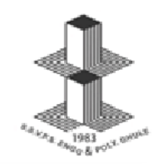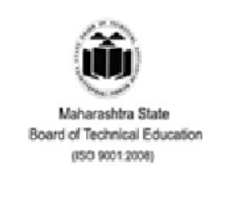

|  |  |
| --- | --- |
| **Pragramme Name : Computer Engineering**  **Program Code : CO3I** | **Academic Year : 2022-2023** |
| **Course Name : Object Oriented Programming Using C++**  **Course Code : 22316** | **Semester : III** |

**A STUDY ON**

Bank Management System using C++

***MICRO PROJECT REPORT***

**Submitted in Dec 2022 by the group of 5 students**

|  |  |  |  |  |
| --- | --- | --- | --- | --- |
| **Sr.**  **No** | **Roll No** | **Full name of Student** | **Enrollment**  **No** | **Exam Seat No** |
| 1 | 17 | Deore Samarthya Ravindra | 2100590064 | 317322 |
| 2 | 24 | Gangurde Suprabha Dinesh | 2100590071 | 317329 |
| 3 | 32 | Jain Ekta Vinod | 2100590079 | 317337 |
| 4 | 52 | Makhija Dhruv Harish | 2100590102 | 317357 |
| 5 | 84 | Patil Rasika Sunil | 2100590135 | 317388 |

# Under the Guidance of

**Mr. C. P. Bhamare**

in

Three Years Diploma Programme in Engineering & Technology of

Maharashtra State Board of Technical Education, Mumbai (Autonomous)

ISO 9001: 2008 (ISO/IEC-27001:2013)

at

**0059 - Shri Shivaji Vidya Prasarak Sanstha’s**

**Bapusaheb Shivajirao Deore Polytechnic,Vidyanagari, Deopur, Dhule-424005.**

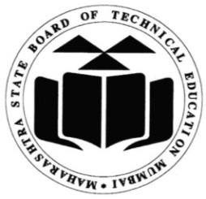

**MAHARASHTRA STATE BOARD OF TECHNICAL EDUCATION, MUMBAI**

***Certificate***

# This is to certify that ,

|  |  |  |  |  |
| --- | --- | --- | --- | --- |
| **Sr.**  **No** | **Roll No** | **Full name of Student** | **Enrollment**  **No** | **Exam Seat No** |
| 1 | 17 | Deore Samarthya Ravindra | 2100590064 | 317322 |
| 2 | 24 | Gangurde Suprabha Dinesh | 2100590071 | 317329 |
| 3 | 32 | Jain Ekta Vinod | 2100590079 | 317337 |
| 4 | 52 | Makhija Dhruv Harish | 2100590102 | 317357 |
| 5 | 84 | Patil Rasika Sunil | 2100590135 | 317388 |

# students **of Third Semester, Diploma Programme in Engineering & Technology** at **0059 - Shri Shivaji Vidya Prasarak Sanstha’s Bapusaheb Shivajirao Deore Polytechnic- Dhule,** has completed the **Micro Project** satisfactorily in Subject **Object Oriented Programming Using C++ (22316)** in the academic year 2022-2023 as prescribed in the MSBTE curriculum of I Scheme.

# Place: Dhule

# Date : 19 / 12 / 2022

**Project Guide Head of the Department Principal**

Seal of Institute